DIS-AM,C-Taino-Frog

The frog for the Taino had two dimensions: sexual and seasonal. Its male rutting period and its female fertility is associated with rainfall. Analogously during this period women are believed to be more accessible to men. Woman in childbirth is viewed as the consummate fertility symbol represented by the Taino cemi, Attabeira, whom Levi-Straus suggests is similar to a frog (Levi-Straus 1973: 66-67) who is depicted in petroglyphs surrounding the many ball-courts in the Greater Antilles.

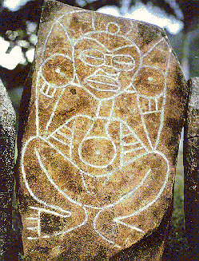

Attabeira (Atabeyra /Atabey/Atabex): The Earth Mother in her childbirthing imge likened unto a frog by Levi-Strauss.

This supreme feminine deity was revered as the feminine counterpart of the earth god Yúcahu, who is also depicted as a male frog in cemis.

References

Levi-Straus, Claude. 1973. *From Honey to Ashes*. New York: Harper and Row.